C.Sc. Project File
Second Term (2018-19)

Q1.) Write a SQL Statement to display A String “ This is SQL Exercise, Practice and Solutions”.

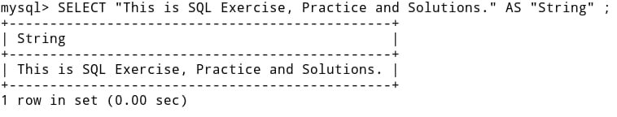

Q2.) Create Database Sales and Use it.

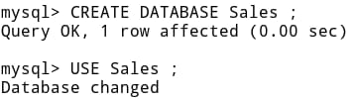

Q3.) Create All above mentioned tables and insert values into them

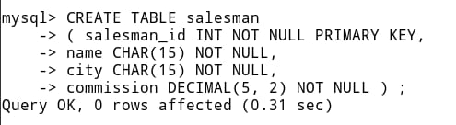

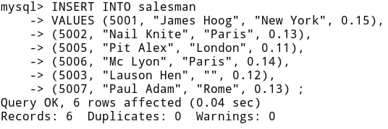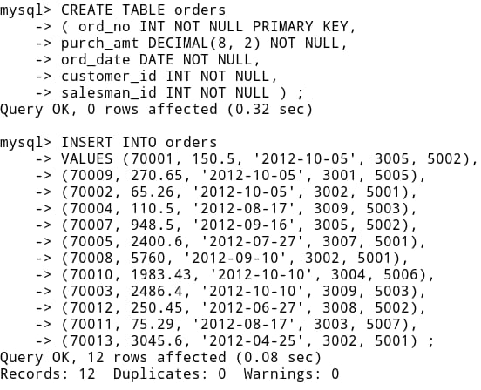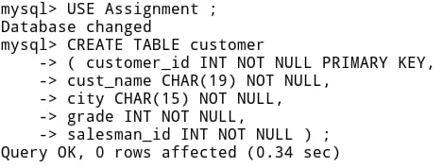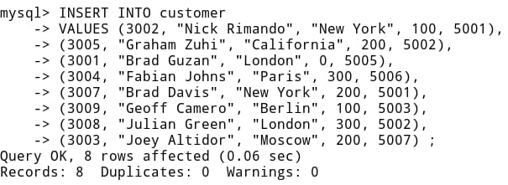

Q4.) Write a Query to display three numbers

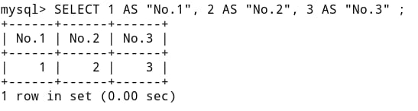

Q5.) Write a SQL Statement to display specific columns like name and commission for all the salesman

Q6.) Write a query to display the columns in a specific order like order date, salesman id, order number and purchase amount from for all the orders
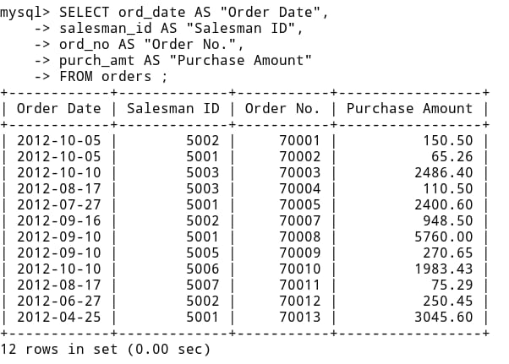

Q7.) Write a SQL statement to display all the information for those customers with a grade of 200

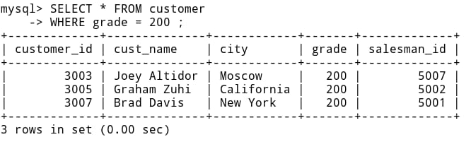

Q8.) Write a SQL query to display the order number followed by order date and the purchase amount for each order which will be delivered by the salesman who is holding the id=5001

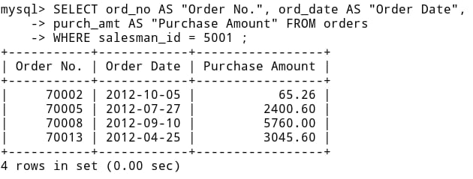

Q9.) Concatenate customer name and salesman id for those having grade 200 or 300.

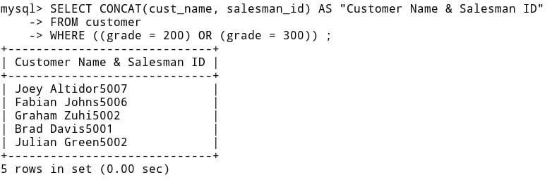

Q10.) Display names of the cities from customer table in lower case.

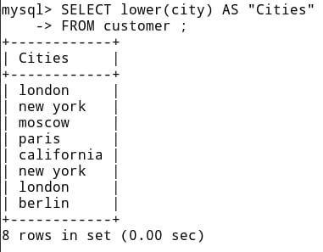

Q11.) Display first five characters extracted from salesman table of salesman whose id is 5001 and 5003

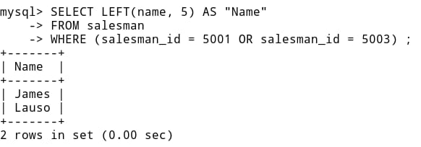

Q12.) Display the position of string “RK” in field city of salesman table.

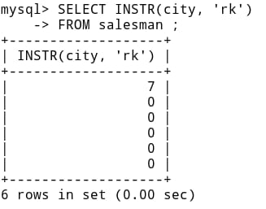

Q13.) Write a query to extract month part from ord_date in order table

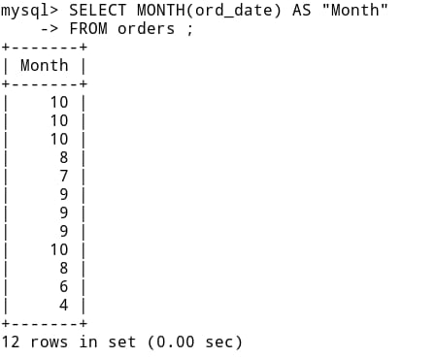

Q14.) To list all order numbers with orders date in the descending order.

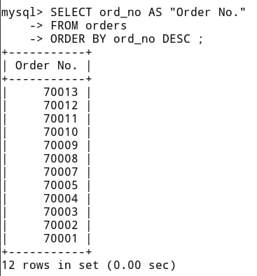

Q15.) Modify commission and increase it by 0.10 of all salesman whose city is “Paris”.

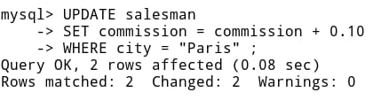

Q16.) Change the date type of column cust_name to varchar(45) in the table customer.

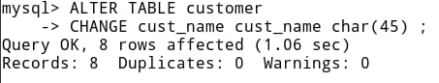

Q17.) Add one column email of data type varchar and size 40 to the table salesman

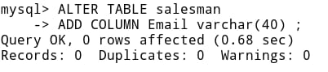

Q18.) Update city “Australia” from salesman id 5003.

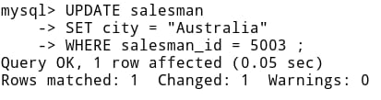

Q19.) To display ord_no, ord_date, customer_id with corresponding name.

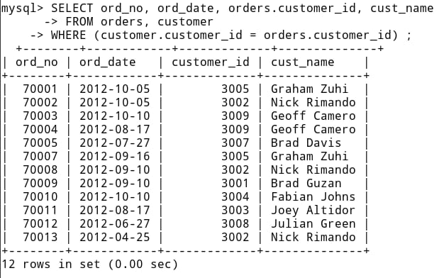

Q20.) List the salesman name and the number of their customer.
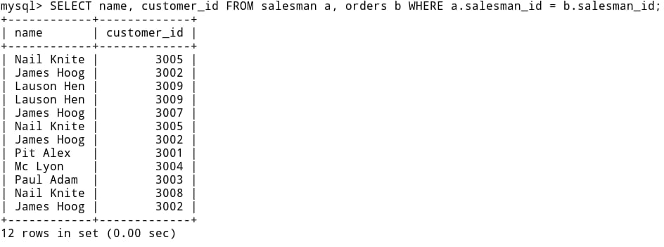

Q21.) Increase the commission of all the salesman by 0.30.

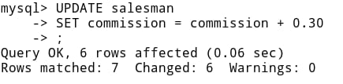

Q22.) Find out the commission taken by all salesman with order no, whose purchase amount is grater than 1500.

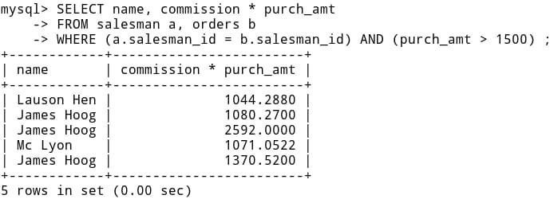

Q23.) Create index on ord_date field on table orders.

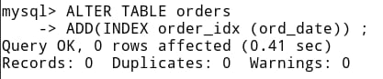

Q24.) Write a query to create a string from the ASCII values 69,70,67,79,79.

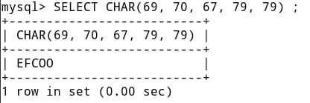

Q25.) Write a query to display current date and time.

